OUTPUT :
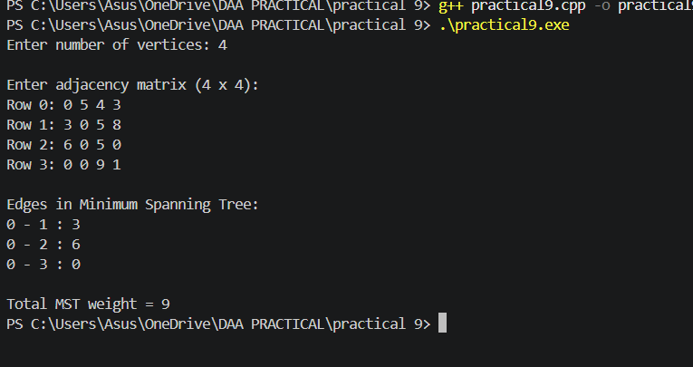
Conclusion:
Thus, Prim’s Algorithm was successfully implemented to find the Minimum Spanning Tree (MST) of a weighted graph. The algorithm selects the minimum-weight edge at each step and connects all vertices with minimum total cost without forming cycles.

